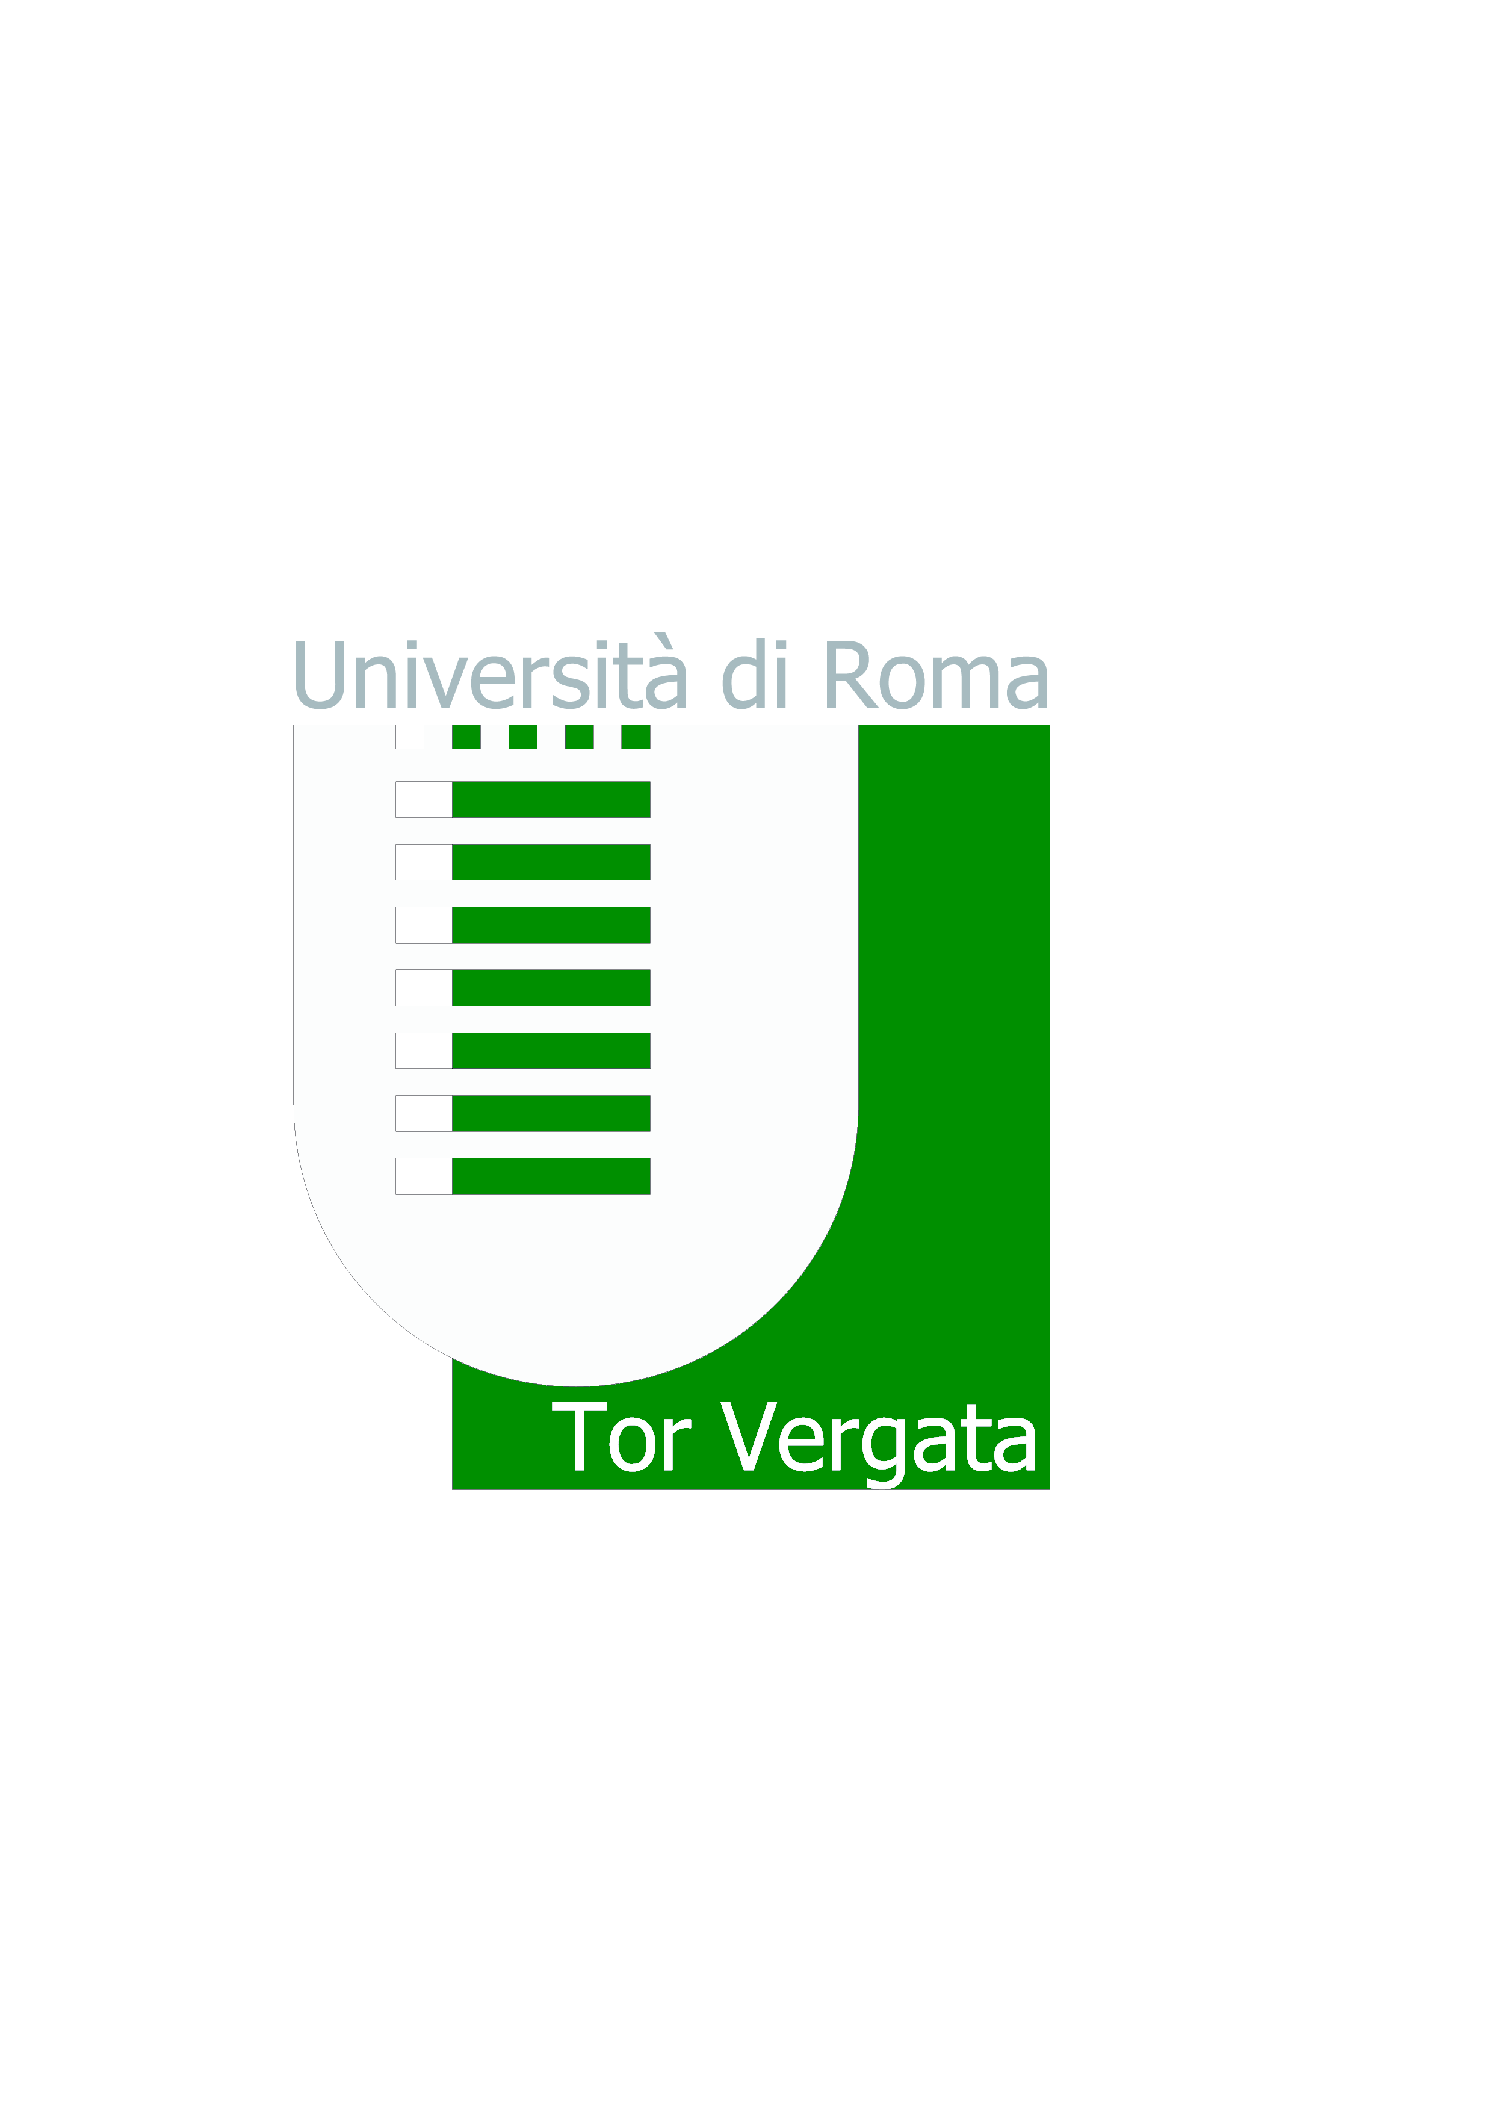
Università degli Studi di Roma “TOR VERGATA”
MACROAREA DI LETTERE E FILOSOFIA
Ufficio Tirocini Didattico-Curriculari - Via Columbia, 1-00133 Roma

CALL/PROPOSAL FOR CURRICULAR TRAINING

Eurolink Srl offers n. 4 internships with the following selection criteria:
Objectives and modalities:
The resource will carry out the internship at Italy Best Golf. The trainee will be trained on the main themes/topics/processes of the creation of a tourist offer. The internship consists in the research and development of golf holiday packages to be published on the portal www.italybestgolf.com. The research includes the selection of special areas related to golf sports tourism, on which will be organized the development of special modular golf holiday packages. The activity specifically provides for:
- identification and selection of areas linked to golf sports tourism;
- creation of a 360-degree tourist offer on the territory under consideration (accomodation, golf courses, food and wine tours, cultural tours, experiences, spa and spa, transfer...);
- the inclusion of tour packages in the platform;
- contacts with local operators;
- promotion and internationalization of packages.

Requirements for the following:

• Use of the Office packages;

• Good knowledge of English;

• University curriculum with list of exams.

Degree Courses:
• Sciences of Tourism (Scienze del Turismo);
• Tourism Strategy, Cultural Heritage and Made in Italy.

Place of internship:

• Smartworking with the possibility to come to headquarters (Via Girolamo Segato, 31 - 00147 Roma)

Interneship duration
• Daily working hours: 4
• 3 months (150 hours - 6CFU) or 6 months (300 hours - 12CFU)

Starting date of the project
- January 2022

Reimbursement of expenses
No reimbursement of expenses

Interested parties can send their application to the following e-mail address:
c.lucaferri@italybestgolf.com by 24/12

