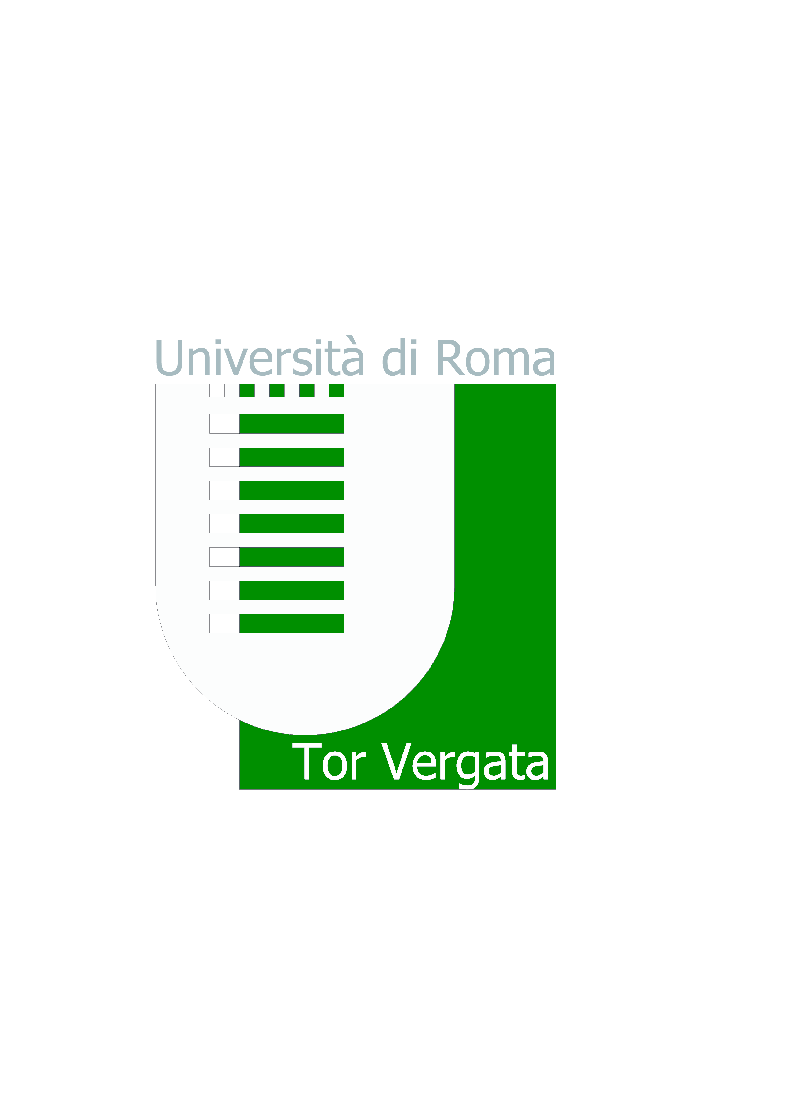
Università degli Studi di Roma “TOR VERGATA”
MACROAREA DI LETTERE E FILOSOFIA
Ufficio Tirocini Didattico-Curriculari - Via Columbia, 1-00133 Roma

CALL/PROPOSAL FOR CURRICULAR INTERNSHIP

Eurolink Srl offers internships with the following selection criteria:

Objectives and modalities:
The resource will carry out the internship for the Bestime.golf company. At the moment company is expanding to the worldwide level, thus new human resources are needed.

The trainee will be trained on the main themes/topics/processes of the creation of a tourist offer. The internship consists of the research and development of the worldwide golf holiday packages to be published on the portal www.bestime.golf. The research includes the selection of special areas related to golf sports tourism, on which will be organized the development of special modular golf holiday packages.

The activity specifically provides for:

- identification and selection of areas linked to golf sports tourism;
- worldwide research for tourist infrastructure in potentially significant areas for golf;
- creation of a 360-degree tourist offer on the territory under consideration (accommodation, golf courses, food and wine tours, cultural tours, experiences, spa and spa, transfer...);
- downloading of tour packages to the platform of Bestime.golf;
- contacts with operators and service suppliers in all over the world;
- promotion and internationalization of packages;
- assistance in organizing corporate events.

Requirements for the following:

• Use of the Office packages;

• Good knowledge of English;

• University curriculum with list of exams

• Italian or other foreign native language.

Courses of Degree:
• Sciences of Tourism (Scienze del Turismo);
• Tourism Strategy, Cultural Heritage and Made in Italy.

Place of internship:

• Smartworking with the possibility to come to headquarters (Via Girolamo Segato, 31 - 00147 Roma)

Interneship duration
• Daily working hours: 4
• 3 months (150 hours - 6CFU) or 6 months (300 hours - 12CFU)

Starting date of the project
- February 2023

Reimbursement of expenses
No reimbursement of expenses

Send your application with CV to the following e-mail address:
b2b-service@italybestgolf.com; p.garlando@italybestgolf.com

